A Major Project Mid-Term Report
on
QRCard - QR Based Digital Visiting Card

Submitted in the Partial Fulfillment of the Requirements for Degree of
Bachelor of Computer Applications
Under Pokhara University

Submitted by:
Anisha Pakhrin, 222006
Pujan Poudel, 222027
Rajan Kshedal, 222049
Sanchita Thapa Magar, 222047

Under the supervision of
Er. Roshan Chitrakar

Date:
May 29, 2025


Department of Bachelor of Computer Applications
NEPAL COLLEGE OF
INFORMATION TECHNOLOGY
Balkumari, Lalitpur, Nepal

ABSTRACT
QR-based Digital Visiting Card and Profile Sharing Web Application is a smart web-based system designed to make personal and professional contact sharing faster, easier, and more modern. Traditional paper visiting cards can be lost, damaged, or outdated, while NFC-based cards [1] increase cost due to the need for special hardware. This project provides a cost-effective alternative by allowing users to create digital profiles and share their information through QR codes [2]. The system supports online QR codes that redirect users to a public profile page and offline QR codes that store contact details in vCard format for saving contacts without internet access. It also includes custom visiting card design and printing order features. In addition, the system uses AI through the Gemini API to generate professional bios and provide profile improvement suggestions using a Profile Completeness Score. By combining QR technology, AI assistance, and digital profile management, this project aims to provide a simple, affordable, and effective solution for modern networking.

Keywords: QR Code [2], Digital Visiting Card, vCard [3], AI Bio Generator, Gemini API [4], Profile Sharing, Online QR, Offline QR, Profile Completeness Score, Digital Networking

Table of content

ABSTRACT ii
LIST OF TABLES v
LIST OF FIGURES vi
1 INTRODUCTION 1
1.1 Introduction 1
1.2 Problem Statement 2
1.3 Project Objective 3
1.4 Significance of the Project 3
1.5 Scope and Limitations 4
1.5.1 Scope of the Project 4
1.5.2 Limitations 4
2 LITERATURE REVIEW 5
2.1 Review of Existing Systems 5
2.2 Comparative Analysis Between Existing Application & QRCard 10
3 METHODOLOGY 11
3.1 Software Development Life Cycle 11
3.1.1 Requirement Analysis 12
3.1.2 System Design 12
3.1.3 Coding 12
3.1.4 Testing and Evaluation 12
3.2 Tools and Technology Used 13
3.2.1 React.js & Tailwind CSS 13
3.2.2 Node.js and Express.js 14
3.2.3 PostgreSQL 14
3.2.4 JWT [6] & Bcrypt [7] 14
3.2.5 Gemini API [4] 14
3.2.6 Visual Studio Code/ Antigravity 14
3.2.7 Diagrams.net 14
3.2.8 OnlineGantt 14
3.3 Roles and Responsibility 15
4 SYSTEM DESIGN AND ARCHITECTURE 16
4.1 Flowchart 16
4.2 Use Case Diagram 17
4.3 ER Diagram 18
4.4 Data Flow diagram 19
4.5 Data Flow Diagram 20
5 PROPOSED DELIVERABLES 20
6 PROJECT TASK AND TIME SCHEDULE 22
6.1 Gantt Chart 23

7 Bibliography 24

LIST OF TABLES
Table 1: Comparative Analysis of Profile Sharing Application 9
Table 2: Technology Used 12
Table 3: Members and Task 14

LIST OF FIGURES
Figure 1: Incremental Model of Software Engineering 10
Figure 2: Flowchart 15
Figure 3: Use Case Diagram 16
Figure 4: ER Diagram 17
Figure 5: Data Flow Diagram 17
Figure 6: gantt chart 20

INTRODUCTION

Introduction
In today’s digital world, sharing personal and professional information quickly and conveniently has become important. Traditional paper visiting cards are still commonly used, but they can be lost, damaged, or become outdated when contact details change. Reprinting cards also increases cost and paper usage.
This project proposes a QR-based Digital Visiting Card and Profile Sharing Web Application. The system allows users to create a digital profile and share their contact information through QR codes. It supports an online QR code that redirects users to a public profile page and an offline QR code that stores contact details in vCard format, allowing the receiver to save the contact even without an internet connection.
The system also includes a custom visiting card design feature where users can choose the QR type, preview a minimal card design, and place an order for printing. In addition, artificial intelligence is integrated using the Gemini API [4] to generate professional bios and provide profile improvement suggestions through a Profile Completeness Score feature.
Overall, this project aims to provide a smart, simple, and modern solution for digital networking. It reduces the limitations of traditional visiting cards and helps individuals, students, professionals, freelancers, and businesses share their identity and contact details more effectively.

Problem Statement
Sharing personal and professional contact information is still commonly done through traditional paper visiting cards. However, these cards can be easily lost, damaged, or become outdated when users change their phone number, email, job title, company details, or social media links. In the digital age, users need a faster, smarter, and more flexible way to share their identity and contact details.
Although NFC-based digital cards are available, they usually require special NFC chips or cards, which increases the overall cost for users. Similarly, some existing QR-based and digital profile solutions only provide basic contact sharing and do not support both online and offline access. They also often lack customization, profile improvement guidance, and integration with physical visiting card printing. The key problems this project aims to address are:
- Loss or Damage of Traditional Paper Visiting Cards
- Difficulty in Updating Printed Contact Information
- High Cost of NFC-Based Digital Cards
- Lack of Offline Contact Saving Support, (Internet Dependency)
- Limited Customization in Existing Digital Card Systems
- Absence of AI-Based Profile Improvement Features
- No Integrated Visiting Card Design and Printing Option
This project addresses these issues by developing a QR-based Digital Visiting Card and Profile Sharing Web Application. The system allows users to create a digital profile, generate online and offline QR codes, design minimal visiting cards, and use AI features such as bio generation and profile completeness suggestions. This provides a modern, intelligent, and user-friendly solution for personal and professional networking. One card used any time, from anywhere.

Project Objective
The main objective of this project is to develop a QR-based Digital Visiting Card and Profile Sharing Web Application that allows users to create, manage, and share their contact information easily through QR codes.
The specific objectives of this project are:
- To create digital user profiles for storing personal, professional, and contact details.
- To generate online and offline QR codes for profile sharing and vCard-based contact saving.
- To provide a custom visiting card design feature with QR code preview and printing order option.
- To integrate AI features such as professional bio generation and profile improvement suggestions.
- To provide a simple, secure, and cost-effective alternative to traditional paper cards and expensive NFC-based digital cards.
- To replace traditional paper bases visiting cards and to create a more sustainable, modern, advanced and cheaper way of networking.

Significance of the Project
The development of the QR-based Digital Visiting Card and Profile Sharing Web Application represents an important step toward modernizing personal and professional networking. In a time where digital identity and quick information exchange are becoming increasingly important, this project provides a smart, affordable, and accessible solution for sharing contact details. Unlike traditional paper visiting cards, which can be lost, damaged, or outdated, this system allows users to manage and update their information digitally. It also avoids the high cost of NFC-based cards by using QR technology, making the system more practical for students, professionals, freelancers, and businesses.
- By using QR codes, the system enables users to share their personal and professional information quickly and conveniently through smartphones without requiring special hardware.
- The online QR feature allows receivers to access a user’s public digital profile, making it easier to view updated contact details, professional information, and social media links in one place.
- The offline QR feature stores contact details in vCard format, allowing receivers to save contact information even without an internet connection.
- The use of AI through the Gemini API helps users generate professional bios and improve their profile quality through profile completeness suggestions.
- The system reduces the dependency on traditional paper visiting cards, helping to lower printing costs and support a more eco-friendly approach to networking.
- The exclusion of NFC technology helps reduce hardware cost and makes the platform more affordable for a wider range of users.
- The custom visiting card design and printing order feature connects digital profile sharing with physical card usage, making the system practical for real-world networking.
- Overall, this project provides a simple, cost-effective, and modern platform that supports digital identity management and improves the way people share contact information.

Scope and Limitations

Scope of the Project
The scope of this project is to develop a QR-based Digital Visiting Card and Profile Sharing Web Application that allows users to create and manage digital profiles. Users will be able to store their personal details, professional information, contact details, and social media links in one place.
The system will generate two types of QR codes: an online QR code that redirects to the user’s public profile page, and an offline QR code that stores contact details in vCard format. The project will also include a custom visiting card design feature where users can preview a minimal card design with a QR code and place an order for printing.
The system will include AI-based features such as professional bio generation and profile completeness suggestions using the Gemini API. It will focus on providing a simple, secure, and cost-effective platform for digital networking.
This project is limited to digital profile creation, QR code generation, AI-assisted profile improvement, and visiting card design/printing order features.

Limitations
Although the QR-based Digital Visiting Card and Profile Sharing Web Application provides a modern solution for contact sharing, it has some limitations.
- Internet is required for online QR profiles, because the public profile page can only be viewed when the receiver has internet access.
- Offline QR codes can store only limited information, as vCard format may not support all profile details such as images, portfolio details, and long descriptions.
- NFC functionality is not included in this project, because adding NFC cards or NFC chips would increase the overall cost of the system.
- AI-generated bios and suggestions may not always be perfect, so users may need to review and edit the generated content manually.
- The system depends on the Gemini API for AI features, so AI functions may be affected if the API service is unavailable or limited.
- Printing and delivery depend on vendors, so card printing quality, delivery time, and availability may be affected by third-party printing service providers.
- Printing order management is limited to basic order placement, and advanced features such as online payment, delivery tracking, and vendor management may not be included in the first version.
- Users need a QR scanner or smartphone camera to access the shared profile or save contact.

LITERATURE REVIEW

Review of Existing Systems
In this section, we review existing applications and platforms that provide services similar to the proposed QR-based Digital Visiting Card and Profile Sharing Web Application. This review focuses on digital business card platforms, QR-based profile sharing, NFC-based cards, and contact management features. It highlights the strengths and limitations of these platforms and identifies the gaps that this project aims to address.

1. Zalient
Zalient is a Nepal-based smart digital business card platform that mainly focuses on NFC-based contact sharing. It allows users to share their professional profile and contact details by tapping an NFC card on a compatible smartphone. The platform provides a modern alternative to traditional printed visiting cards.
Strengths:
- Provides smart NFC-based contact sharing.
- Offers a modern and professional way to share digital profiles.
- Useful for business networking and personal branding.
Limitations:
- NFC cards require special hardware, which increases the overall cost.
- NFC sharing may not work properly on all smartphones if NFC is not supported or enabled.
- It mainly focuses on NFC-based sharing and may not provide strong offline vCard-based QR contact saving.
- AI-based profile bio generation and profile completeness suggestions are not a major focus.
2. HiHello
HiHello is a popular digital business card platform that allows users to create and share digital cards through QR codes, links, email, text messages, NFC, and wallet options. It is widely used for professional networking and contact sharing.
Strengths:
- Supports multiple sharing methods such as QR code, link, email, SMS, NFC, and wallet.
- Allows users to create professional digital business cards.
- Recipients can view the card without needing to install the app.
Limitations:
- Some advanced features may require paid plans.
- The platform is not specifically designed for the Nepali market or local business card printing needs.
- It may be more feature-heavy than required for simple users.
- It does not mainly focus on AI-generated professional bios and profile improvement suggestions.

3. Blinq
Blinq is a digital business card application that allows users to create and share their business cards using QR codes, links, tap sharing, and wallet options. It is designed for individuals and teams who want a quick and professional way to share contact information.
Strengths:
  - Provides easy sharing through QR codes, links, tap, and wallet.
  - Does not require the receiver to install the app to view the profile.
  - Supports professional profile customization and team-based card management.
Limitations:
  - Some business and team features may be paid.
  - It may not provide offline vCard QR support for saving contacts without internet.
  - It is not focused on local printing order management.
  - AI-assisted profile improvement features are limited.
4. Popl
Popl is a digital business card and lead capture platform that supports NFC cards, QR codes, and contact management. It is mainly useful for events, conferences, sales teams, and business networking.
Strengths:
  - Supports NFC and QR-based contact sharing.
  - Provides lead capture and contact management features.
  - Useful for business events, expos, and professional networking.

Limitations:
- Many features are more suitable for sales teams and enterprises rather than simple users.
- NFC-based products can increase the cost for users.
- The platform may be complex for basic digital visiting card needs.
- It does not focus on local visiting card design and printing order support.
5. Mobilo
Mobilo is a smart business card platform that combines NFC cards, QR codes, digital profiles, and contact management features. It allows users to update their contact information digitally and share it repeatedly through the same card.
Strengths:
- Supports NFC and QR-based profile sharing.
- Allows users to update their contact information digitally.
- Provides professional features such as analytics and CRM-related options.
Limitations:
  - NFC-based cards may increase the initial cost.
  - Some advanced features may be more suitable for businesses and teams than individual users.
  - It may not provide a simple local printing order workflow.
  - AI-based bio generation and profile completeness scoring are not the main focus.

Comparative Analysis Between Existing Application & QRCard
Feature/Aspect | Zalient | HiHello | Blinq | Popl | QRCard
Digital Profile Creation | Yes | Yes | Yes | Yes | Yes
QR Code Sharing | Limited/Yes | Yes | Yes | Yes | Yes
Online Public Profile | Yes | Yes | Yes | Yes | Yes
Offline vCard QR Support | Limited/No | Limited | Limited | Limited | Yes
NFC Support | Yes | Yes | Yes | Yes | No (to reduce cost)
Cost Effectiveness | Moderate/High due to NFC | Freemium/Paid | Freemium/Paid | Paid/Business focused | Cost-effective
AI Bio Generator | No/Limited | No/Limited | No/Limited | Limited AI for lead capture | Yes (Gemini API)
Profile Completeness Suggestions | No/Limited | Limited | Limited | Limited | Yes

Table 1: Comparative Analysis of Profile Sharing Application

METHODOLOGY
We have deliberately chosen the following methodologies to effectively apply our expertise, skills and techniques, ensuring precise alignment with project requirements.

Software Development Life Cycle
For the software development process of our project, we have adopted the Incremental Model, which allows the system to be developed step by step through multiple iterations. Each iteration includes important phases such as requirement analysis, system design, implementation, and testing. This approach helps in developing the basic features first and gradually adding more advanced features as the project progresses.
In the initial iteration, the main focus will be on implementing the core functionalities of the system, such as user registration and login, digital profile creation, contact information management, and QR code generation. This will establish the basic structure of the QR-based Digital Visiting Card and Profile Sharing Web Application.
In the later iterations, additional features such as offline vCard QR generation, custom visiting card design, card preview, printing order placement, AI-based bio generation, and profile completeness suggestions will be added. These improvements will enhance the usability, intelligence, and practical value of the system. The following subsection explains how the Incremental SDLC model will be applied throughout the development of this project.
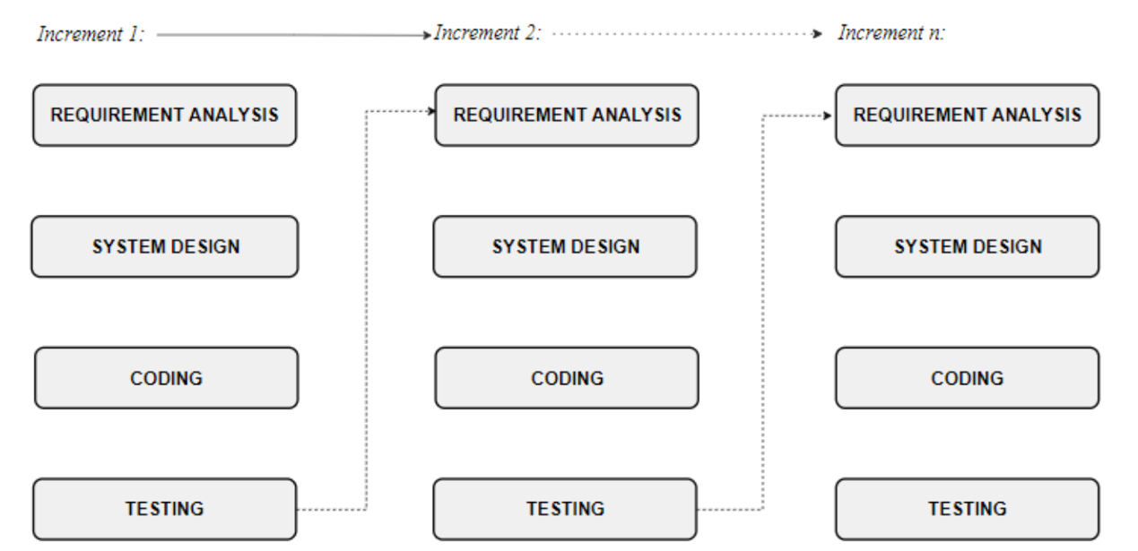

Figure 1: Incremental Model of Software Engineering

Requirement Analysis
In the Requirement Analysis phase, the main focus will be on identifying and documenting the required features and expectations of the system. This includes user registration and login, digital profile creation, contact information management, online and offline QR code generation, AI-based bio generation, profile completeness suggestions, and visiting card design with printing order support. The outcome of this phase will be a clear System Requirement Specification (SRS) document that defines what the system should achieve and guides the overall development process.

System Design
After completing the requirement analysis, the System Design phase will focus on planning the structure, layout, and workflow of the application. Tools such as Figma or similar design tools can be used to create wireframes and user interface designs. The design phase will also include planning the system architecture, database structure, API flow, user profile management, QR generation process, and printing order workflow. This phase ensures that the system design matches the project requirements before actual development begins.

Coding
In the Coding phase, the planned design and requirements will be converted into a working web application. The frontend of the system can be developed using React.js, while the backend can be built using Node.js and Express.js. A database such as PostgreSQL or MongoDB can be used to store user details, profile information, QR data, and printing orders. The Gemini API will be integrated for AI-based bio generation and profile improvement suggestions. Each feature will be developed step by step according to the incremental model.

Testing and Evaluation
After development, each module of the system will be tested carefully to ensure that it works correctly. This includes testing user login, profile creation, QR code generation, offline vCard saving, AI bio generation, profile completeness suggestions, card preview, and printing order placement. The system will also be checked for errors, usability issues, and security problems. Testing and evaluation will help ensure that the application is stable, reliable, secure, and easy to use.

Tools and Technology Used
Tools | Purpose
React.js, Tailwind CSS | Frontend
Node.js, Express.js | Backend
Postman | API Testing/ Documentation
PostgreSQL [5, 2] | Database Management
VS Code, Antigravity | IDE
GitHub | Version Control System
Diagrams.net | Diagrams
Authentication | JWT [6], bcrypt [7]
AI Integration | Gemini API [4]
MS Word | Documentation
MS PowerPoint | Presentation
OnlineGantt.com | Gantt Chart

Table 2: Technology Used

React.js & Tailwind CSS
React enables the creation of reusable UI components and handles dynamic updates, while Tailwind CSS ensures responsive design and faster styling. Together, they provide a clean, interactive user experience.

Node.js and Express.js
Node.js allows JavaScript to run on the server, and Express.js provides a lightweight framework for building RESTful APIs. This combination ensures fast and reliable backend services.

PostgreSQL
PostgreSQL is a powerful open-source relational database used to store structured project data such as user accounts, digital profiles, contact details, QR code information, and printing order records. It helps manage data securely and ensures consistency, reliability, and proper organization of the system’s information.

JWT [6] & Bcrypt [7]
JSON Web Tokens (JWT [6]) are used for secure, stateless user authentication, while bcrypt [7] hashes passwords to enhance security and prevent unauthorized access.

Gemini API [4]
Gemini API is integrated to provide AI-based features in the system. It helps generate professional bios based on user details and provides profile improvement suggestions through the Profile Completeness Score, making the platform more intelligent and useful than a basic digital visiting card system.

Visual Studio Code/ Antigravity
Visual Studio Code and Antigravity are used as development tools for writing, editing, debugging, and managing the project code. Visual Studio Code helps in developing the frontend and backend modules with useful extensions, while Antigravity provides AI-assisted support for code generation, debugging, and faster development.

Diagrams.net
Used for creating system diagrams (flowcharts, ER diagrams, use case, and sequence diagrams) to document the architecture.

OnlineGantt
Web application used to plan, visualize, and manage project timelines through Gantt charts.

Roles and Responsibility
Team Members | Roles
Anisha Pakhrin | Documentation and Testing
Pujan Poudel | System Design and UI/UX
Rajan Kshedal | Backend Development
Sanchita Thapa Magar | Frontend Development

Table 3: Members and Task

Tasks Done So Far
The project has reached the design and early development stage. The team has completed the main planning, research, user-interface design, initial frontend work, and the basic online and offline QR code generation features. The completed tasks are listed below.
S.N. | Task completed | Description
1 | Requirement analysis | The main users, system modules, features, scope, and limitations were identified and documented.
2 | Study of existing systems | Digital visiting card platforms such as Zalient, HiHello, Blinq, Popl, and Mobilo were reviewed and compared with QRCard.
3 | Technology selection | React.js, Tailwind CSS, Node.js, Express.js, PostgreSQL, JWT, bcrypt, and Gemini API were selected.
4 | UI/UX design | The main user pages and admin pages were designed in Figma, including login, registration, dashboard, profile, QR code, card design, order, and printing-order screens.
5 | System design | The flowchart, use-case diagram, ER diagram, and data-flow diagrams were prepared.
6 | Frontend project setup | The React project structure, routes, shared components, and separate user and admin folders were planned and started.
7 | Initial frontend pages | The landing page and main user-interface pages were prepared based on the approved Figma designs.
8 | Documentation | The proposal content, project schedule, diagrams, and mid-term progress details were organized.
9 | Online QR code generation | The online QR code generation feature was prepared so that a QR code can direct users to their public digital profile page.
10 | Offline vCard QR code generation | The offline QR code generation feature was prepared using vCard data so that receivers can save contact details without internet access.
Table 4: Tasks Done So Far

Results And Discussion
At the mid-term stage, the project has produced a clear system plan and a complete user-interface design. The team now has a common understanding of how users will create profiles, generate QR codes, design visiting cards, and place printing orders.
The Figma designs show the expected flow of the web application. The landing page, authentication pages, dashboard, digital profile page, QR code page, card design page, order page, and printing-order page have been planned. The frontend structure has also been started in React.
The current result is not the final working system because the backend, database, AI integration, complete order processing, and full testing are still in progress. However, the online QR code and offline vCard QR code generation features have been prepared at the current stage. The completed design and initial development work provide a strong base for the remaining development. The Incremental Model is useful because each module can be developed and tested step by step.

Performance Analysis And Validation
At this stage, validation mainly focuses on requirements, design quality, navigation flow, input rules, and technical feasibility. Full performance testing will be carried out after the frontend and backend are integrated.
Validation area | Analysis method | Status
Requirement validation | The proposed modules were checked against the project objectives and scope. | Validated
UI/UX validation | The Figma screens were reviewed for clarity, consistency, and ease of use. | Validated
Navigation validation | The planned links between landing, login, registration, dashboard, profile, QR, card design, and order pages were reviewed. | Validated
Input validation planning | Rules were defined for required fields, valid email addresses, letters-only names, numeric phone numbers, and numeric order quantities. | Planned and partly applied
Responsive design | The interface was planned for desktop and smaller screens. | Partly validated
QR code performance | The online QR and offline vCard QR features were checked with sample data. Full testing on different phones and QR scanners will continue. | Partly validated
Backend and database performance | API response time, database operations, and concurrent requests will be tested after backend development. | Remaining
Security validation | JWT authentication, bcrypt password hashing, access control, and protected routes will be tested after integration. | Remaining
Table 5: Performance Analysis and Validation
The final validation will include functional testing, usability testing, QR scanning tests, API testing through Postman, form-validation testing, security checks, and testing on different screen sizes. Any errors found during testing will be corrected before the final submission.

Tasks Remaining
The following tasks will be completed during the remaining project period:
S.N. | Remaining task | Expected work
1 | Complete frontend development | Finish all user and admin pages and make every required button and form functional.
2 | Develop backend APIs | Create APIs for authentication, profiles, QR codes, designs, orders, admin operations, and analytics.
3 | Configure PostgreSQL database | Create relational tables for users, profiles, QR codes, card designs, orders, order status, and analytics.
4 | Implement authentication | Add registration, login, JWT-based sessions, bcrypt password hashing, protected routes, and user roles.
5 | Develop public profile pages | Display updated user information through a public profile URL.
6 | Integrate Gemini API | Generate professional bios and profile-improvement suggestions.
7 | Complete card design and order modules | Connect card preview, QR selection, order placement, status tracking, and admin management.
8 | Add basic analytics | Track online QR scans, profile views, and user engagement.
9 | Integrate and test the system | Connect the frontend, backend, database, and external services and correct errors.
10 | Complete documentation and presentation | Prepare the final report, user guide, testing results, and final presentation.
Table 6: Tasks Remaining

SYSTEM DESIGN AND ARCHITECTURE

Flowchart
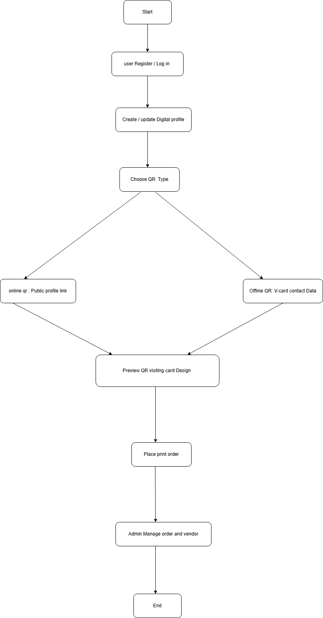

Figure 2: Flowchart

Use Case Diagram
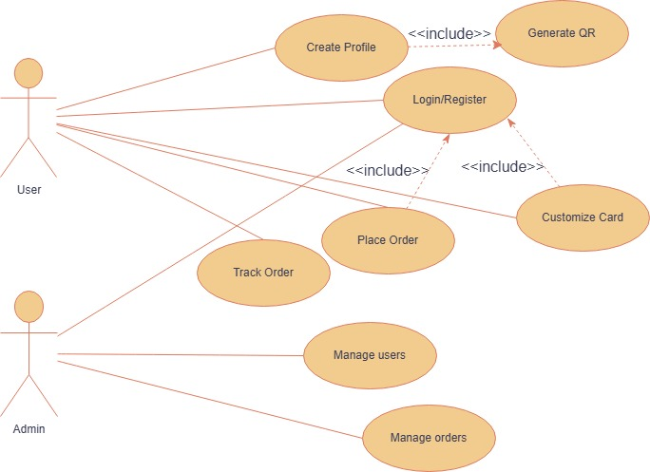

Figure 3: Use Case Diagram

ER Diagram
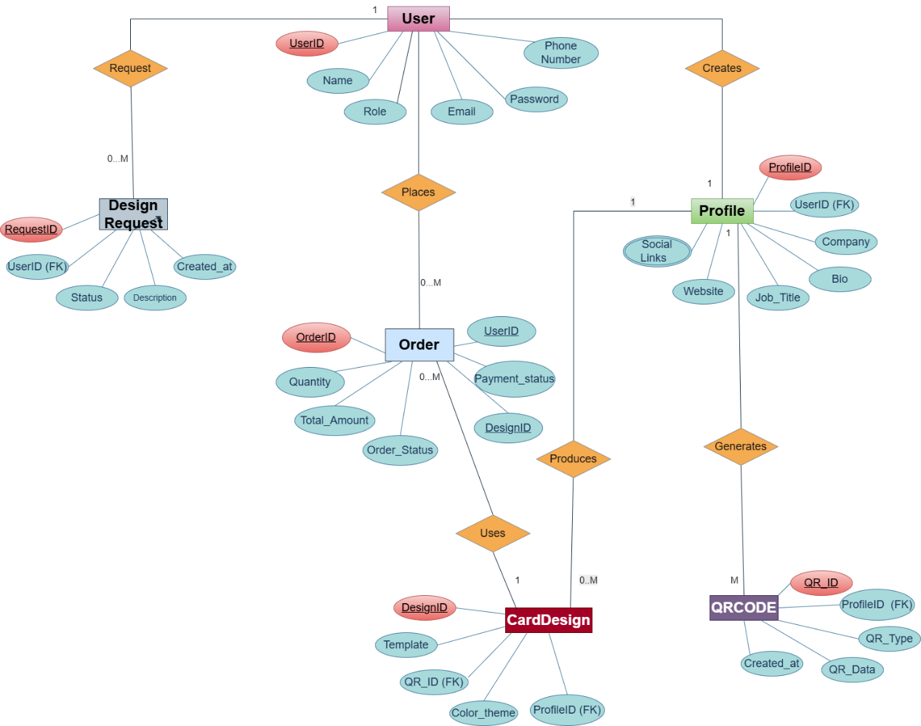

Figure 4: ER Diagram

4.4 Data Flow diagram

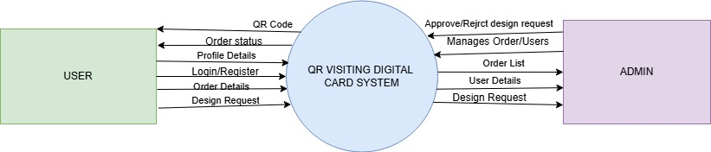

Figure 5: DFD 0

Data Flow Diagram
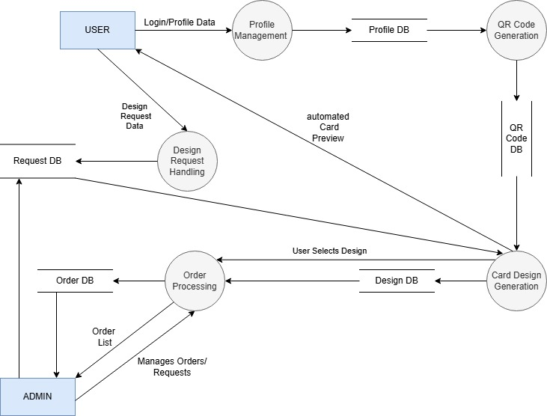

Figure 6: Data Flow Diagram

Proposed Deliverables
The proposed deliverables of the QR-based Digital Visiting Card and Profile Sharing Web Application are:
- User Registration and Login Module: secure authentication system that allows users to create accounts and log in to the application.
- Digital Profile Management Module: module where users can add, update, and manage their personal, professional, contact, and social media information.
- Online QR Code Generation: feature that generates a QR code linked to the user’s public digital profile page.
- Offline vCard QR Code Generation: feature that generates a QR code containing contact details in vCard format, allowing receivers to save the contact without internet access.
- AI Bio Generator: AI-based feature using the Gemini API to generate professional profile bios from user-provided details.
- Profile Completeness Score: feature that checks the completeness of the user’s profile and provides suggestions for improvement.
- Custom Visiting Card Design and Preview: feature that allows users to preview a minimal visiting card design with their selected QR code.
- Printing Order Placement Module: basic module that allows users to place an order for printing their customized visiting cards.
- Final Project Documentation: complete project report including system design, methodology, implementation details, testing, and conclusion.

Project Task And Time Schedule
The project schedule for the QR-based Digital Visiting Card and Profile Sharing Web Application was developed by considering the required system modules, QR code functionality, AI integration, and visiting card design features. The time allocation ensures that the basic components such as user authentication, profile management, and QR generation are prioritized before adding advanced features like AI bio generation, profile completeness suggestions, and printing order support.
Task | Approximate Duration in Days
Requirement Analysis | 10
System Design | 5
User Authentication and Profile Management | 14
Online and Offline QR Code Generation Development | 12
AI Bio Generator and Profile Completeness feature | 10
Custom Visiting Card and Preview Module | 12
Printing Order Placement Module | 8
Frontend and Backend Integration | 10
Testing and Debugging | 8
Documentation | 20

Gantt Chart
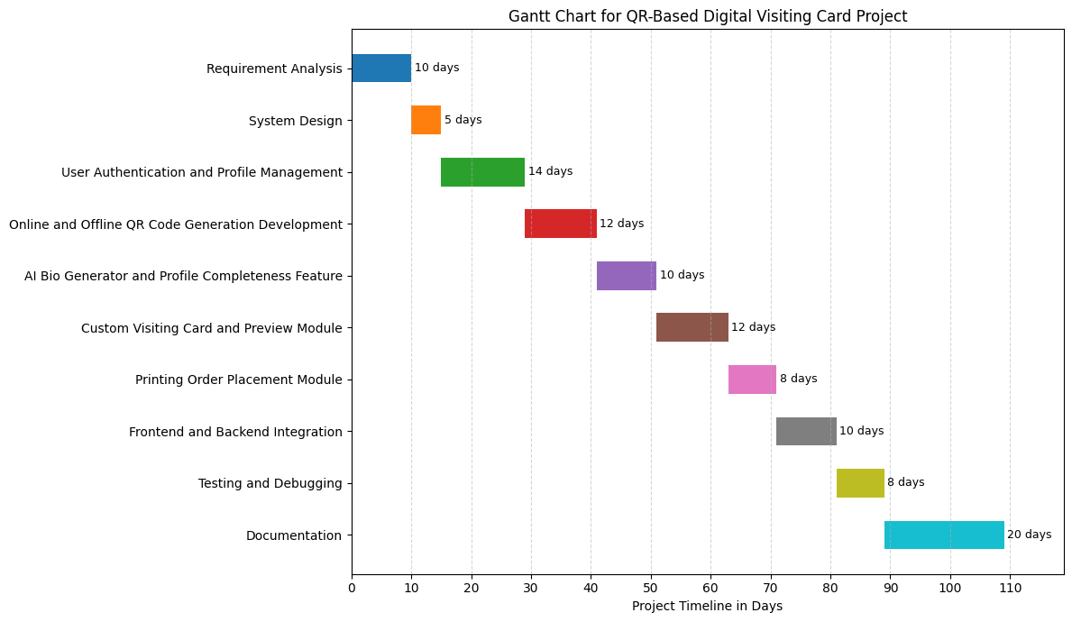
Figure 7: Gantt chart

Bibliography

[1] | M. Nowak, "How do NFC Card Work?," Nomtek, 16 12 2023. [Online]. Available: https://www.nomtek.com/blog/what-are-nfc-tags. [Accessed 28 05 2026].
[2] | Fortinate, "What is a QR Code?," Fortinate, 12 1 2025. [Online]. Available: https://www.fortinet.com/resources/cyberglossary/what-is-a-qr-code. [Accessed 28 5 2026].
[3] | S. Ismail, "What is Vcard?," Sinch, 11 12 2023. [Online]. Available: https://community.sinch.com/t5/SMS/What-is-a-vCard-and-how-do-they-work-nbsp/ta-p/9829. [Accessed 28 05 2026].
[4] | G. A. f. Developers, "Gemini API | Google AI for Developers," Google AI for Developers, 27 June 2025. [Online]. Available: https://ai.google.dev/gemini-api/docs. [Accessed 11 July 2025].
[5] | T. P. G. D. Group, "About," PostgreSQL, 8 May 2025. [Online]. Available: https://www.postgresql.org/about/. [Accessed 11 July 2025].
[6] | Auth0, " Introduction to JSON Web Tokens," jwt.io, [Online]. Available: https://jwt.io/introduction. [Accessed 11 July 2025].
[7] | D. Arias, "Understanding bcrypt," Auth0 Blog, 25 February 2021. [Online]. Available: https://auth0.com/blog/hashing-in-action-understanding-bcrypt/. [Accessed 11 July 2025].

